30 Day Form
Maryland Natural Gas Voucher Program

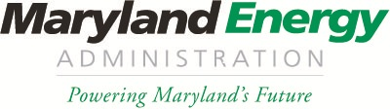

Please fill out this “30 Day Form” for the Maryland Natural Gas Voucher Program, and send to:
Chris Rice via email: crice@energy.state.md.us
Or by mail to:
Attention- Nat Gas Voucher Program
“30 Day Form”
Maryland Energy Administration
60 West Street, Suite 300
Annapolis, MD 21401

Award #
Award Date
PPC Name
Motor Carrier Name
Vehicle Identification #
Vehicle Delivery Date

