120 Day Extension Form
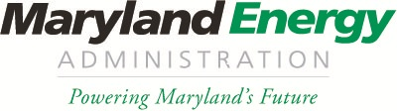
Maryland Freedom Fleet Voucher Program
Larry Hogan, Governor
Boyd K. Rutherford, Lt. Governor
Mary Beth Tung, Director

Please fill out this “120 Day Extension Form” for the Maryland Freedom Fleet Voucher Program and send to:
Program Administration via email: michael.jones1@maryland.gov
Or by mail to:
Attention- FFV Program
“120 Day Form”
Maryland Energy Administration
1800 Washington Boulevard, Suite 755
Baltimore, MD 21230

Award #
Award Date
PPC Name
Motor Carrier Name
Vehicle Identification #
Original Vehicle Delivery Date
New Vehicle Delivery Date

Please provide a justification as to why an extension is required for vehicle delivery below:

