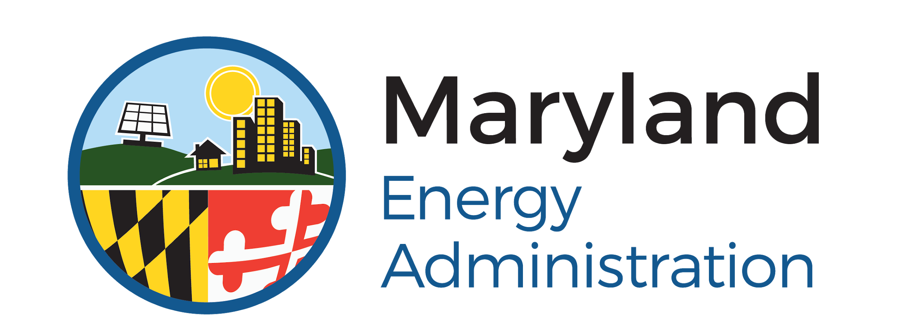

Maryland Smart Energy Communities Program
Deadlines for FY2021
The expected deadlines for the MSEC FY2021 grant program are listed below. Requests for extensions, if necessary, must be sent to MEA at least one month prior to the relevant deadline. Extensions will be considered on a case-by-case basis. Failure to meet the deadlines outlined in the grant agreement may result in cancellation of the grant.

Grant Applications Due – November 13, 2020
The completed grant application must be received by MEA before November 13th, 2020 at 5:00 PM Eastern time. Applications must be complete when first submitted, and proposals from existing communities should include detailed calculations of expected energy reduction and cost savings.

Grant Awards Announced – late January 2021/early February 2021
MEA anticipates notifying applicants of its decisions by late January 2021/early February 2021.

Grant Agreements Signed – Spring 2021
If selected for an award from the FY21 Program, an applicant wishing to participate must provide a signed agreement to MEA by the Spring 2021 deadline, to be determined by MEA.

Project Design Finalized – June 30, 2021
Existing communities must submit completed Project Development forms (Attachment A) by this date. Specification sheets for the main project components must be included with the application, and the energy and cost savings must be clearly substantiated. The project should be in its final design stage. Work cannot begin until the project design has been approved by MEA via the Project Approval form (Attachment B).

Baselines and Policies – October 1, 2021 (New Communities only)
By this date, each New community must adopt at least two of the three MSEC energy policies, as well as submit its energy baselines and action plans. The baseline must be comprehensive and will serve as a roadmap for MSEC funding opportunities. An MSEC community is eligible to receive access to its full award amount only if it has adopted the policy corresponding to the proposed project.

Complete Construction – October 7, 2022
All work must be complete by this date. MEA will consider providing extensions on a case-by-case basis for good cause.

Final Report, Invoices & Reimbursement Request – November 4, 2022
All documentation must be sent via email by this date to MEA (msec.mea@maryland.gov) in order to receive reimbursement. Requested reimbursements should be made on official government letterhead and include the grant number and the grantee’s federal tax identification number. Grantees must submit an Invoice Report Form (Attachment C), as well as vendor invoices, copies of contractor licenses and insurance certificates, staff timesheets (if requesting reimbursement for admin expenses), and photographic documentation of the work performed and completed. The documentation must show that the work has been paid in full and that it matches the scope of work defined in the Project Development form. MEA will not provide funding for work that does not match the project approved by MEA.

