Attachment A
MSEC Project Development Form
(This form denotes the information necessary to approve an MSEC funded project.)

1. Name of Grantee
2. Policies Passed:
Energy Efficiency
Renewable Energy
Transportation Petroleum Reduction
3. Grant Amount
Total Grant Amount:

a. Direct Project Costs: Minimum 70% of total grant amount
b. Policy and Project Preparation Costs: Maximum 30% of total grant amount

4. Project Address
5. Project Type
A project focusing solely on energy efficiency (i.e., a lighting upgrade, adding insulation, etc.)
A project focusing solely on renewable energy/clean transportation (i.e., adding solar panels to your roof)
A project which combines energy efficiency and renewable energy/clean transportation
6. Percentage of Grant Per Funding Track (e.g. energy efficiency, renewable energy, or transportation petroleum reduction)
7. Project Narrative:
8. Total Project Cost, Other Sources of Funding (e.g. Jurisdiction Match, Rebates, Other Grants, etc.)
9. Annual Energy Benefits Estimate (e.g. kWh reduced, kw installed, gallons reduced)
10. Expected Life of the Installed Equipment
11. Simple Payback of the Measures (e.g. project cost/annual savings)
12. Electricity/Fuel Cost Information
Electric utility provider and cost of electricity, $/kWh
Building fuel oil cost ($/gallon)
Natural gas utility provider and cost of natural gas ($/MMcf)
Propane cost ($/gallon)
Gasoline cost ($/gallon)
Diesel cost ($/gallon)
Other fuels not listed above (please specify):
13. Utility Rebates to be Pursued:
14. Documentation of MHT Review (For MEA Use Only)

Attachment B
For MEA Use Only

Maryland Energy Administration
Maryland Smart Energy Communities Program

MEA MSEC Project Approval

The ____________ ___________________________ has been approved to commence with the Maryland Smart Energy Communities project Proposed in Attachment A, as modified, if necessary, in the Scope of Work section, below. The project has been determined to comply with the following requirements of the Maryland Smart Energy Communities program (all requirements must be met before proceeding):

Reviewed to confirm that the proposed project is eligible to receive MSEC funds

Reviewed to verify that the project will reduce electricity consumption and/or generate clean energy and/or reduce petroleum consumption.
Reviewed and determined that the proposed project will have “no adverse effect” on any historic property.
Reviewed to confirm that the Grantee has in place baselines and plans for the two policies they chose to pursue, and has adopted formal, written policies through their legislative or governing body committing the local government to the policies specified in the Policy Guidance Documents

SCOPE OF WORK:
______________________________________________________________________________________________________________________________________________________________________________________________________________________________________________________________________________________________________________________________________________________________________________________________________

EXPECTED USEFUL LIFE (YEARS): ___________

PAYBACK (YEARS, attach calculations as appropriate): ________________

Approved by:

________________________ Date: _______________
Devan Willemsen
Grant Manager, Maryland Energy Administration

Attachment C
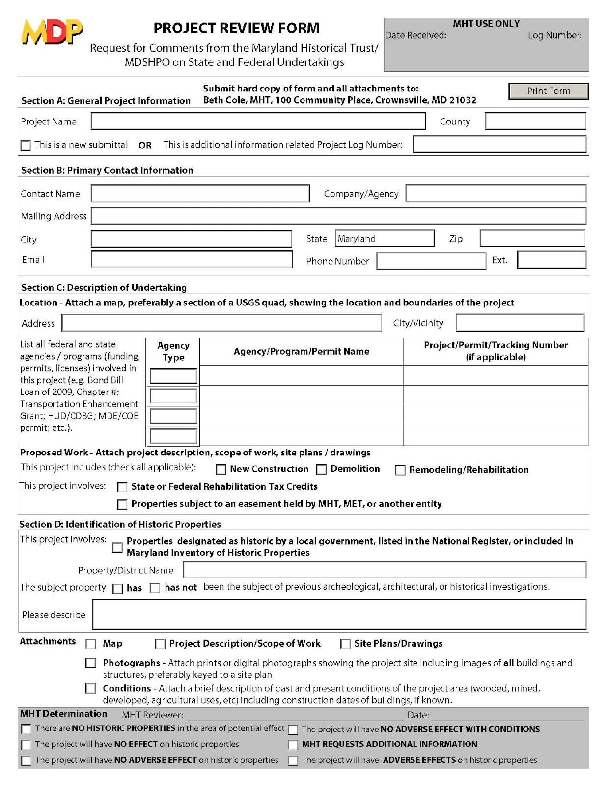

Revised 5/15/2015
Attachment D

Maryland Smart Energy Communities Grant Program Monthly Report

Instructions: Please complete and forward the MSEC Monthly Report to MEA by the 20th day of the month following the prior month’s reporting period.
(Example: Submit the monthly report to MEA by August 20, 2015 for the July 2015 2014 reporting period.)

- Local Government Name and Address: |  | 2. Name/ Title/Phone Number of Report Submitter:
3. Congressional District: |  | 4. Address of Project (if different than the address shown above)
5. Reporting Period  Month: _________  Year: ___________  Is this the final MSEC monthly report?  Yes No |  | 6. MEA Grant Number:
7. Local Government Invoice Number (if invoices are being submitted to MEA for payment): |  | 8. Federal Tax Identification Number:
9. MSEC Grant Expenditures
Please indicate the amount of MSEC grant funds spent during a. the reporting period and b. over the course of the project to date. Please note that if you are receiving funding from the low-to-moderate income SEIF energy efficiency allocation, as specified in Section III of the Grant Agreement, you must track, invoice, and report this funding stream separately.
- MSEC Grant Dollars Spent during this Reporting Period ($) |  | Direct Project Costs (minimum 70% of total Grant amount):
 |  | Policy and Project Preparation Costs (maximum 30% of total Grant amount):
 |  | Total grant funds requested, this reporting period (this number should match the invoiced amount):
- MSEC Grant Dollars Spent to date ($) |  | Direct Project Costs (minimum 70% of total Grant amount):
 |  | Non-Project Costs (maximum 30% of total Grant amount):
 |  | Total grant funds requested, spent to date (this number should match the invoiced amount):
10. Non-MSEC Grant Expenditures
- Utility Rebates ($) |  | - Other Project Expenditures ($)  Please include description of incentive and the $ amount of incentive. If more than one utility incentive is obtained, please list all incentives separately.
11. Policy Status Update
- Provide a brief narrative of the status of the baselines, plans, and policies required under this program. |  | Energy Efficiency:
 |  | Renewable Energy:
 |  | Transportation Petroleum:
12. Project Status Update
- Provide a brief narrative of project milestones and/or accomplishments achieved during the reporting period. Please indicate if any specific energy measure(s) were placed into service during the reporting period.
- Were any obstacles encountered during the reporting period? If so, please explain.

13. Is this your final report? Yes No

If yes, please complete section 14, below. If no, please leave section 14 blank.
14. Reporting Metrics:
The reporting metrics required for your project are listed below. Please enter N/A for any reporting metric that does not apply to your specific project. Grantees will work with their MEA grant manager to customize this section for their specific project.
- Jobs created (Hours worked) Required
Please report the total number of hours worked (and paid for using Grant funds) by Grantee staff, contractors, and vendors
- Energy Cost Savings ($ saved per year due to project) Required
- Building Energy Savings
Required for energy efficiency projects
- Reduction in annual electricity consumption (MWh)
- Reduction in annual fuel oil consumption (gal)
- Reduction in annual natural gas consumption (MMcf)
- Reduction in annual propane consumption (gal)
- [Insert other measure]
- [Insert other measure]
- Renewable Energy Capacity and Generation
Required for renewable energy projects
- Amount of electricity generated by photovoltaic systems (MWh) annually
- Amount of electricity generated by wind systems (MWh) annually
- Amount of electricity
generated by other renewable systems (MWh) annually
- Installed photovoltaic system capacity (MW)
- Installed wind capacity (MW)
- Installed capacity of all other renewable systems (MW)
- [Insert other measure]
- Transportation-Related Energy Savings
Required for transportation petroleum reduction projects
- Reduction in annual gasoline consumption (gal)
- Reduction in annual diesel consumption (gal)
- [Insert other measure]
- [Insert other measure]

- Building Retrofits (number of buildings) – Required

