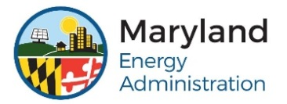
FY20 LDC MATCHING GRANT PROGRAM
Application Checklist
APPLICATION DEADLINE: WEDNESDAY, December 11, 2019
Please use the FY20 Local Distribution Company Grant Application Checklist below to make sure that your FY20 LDC Grant Application is filled out entirely.

Section 1: Organization and Contact Information
☐ Does your organizations name match what’s on your IRS W9 form?
☐ Is the street address filled out?
☐ Is the mailing address filled out, if different than the physical location?
☐ Is the authorized representative filled out?
☐ Is the individual preparing the application filled out?
☐ Is the point of contact filled out, the individual who would manage the grant on a day-to-day basis completed?
☐ Do your organization have a Federal Tax Identification number? If yes, have you attached to the Application Form?
☐ Did you define the county/counties in which hard assets will be located?

Section 2: Proposed Project
☐ Have you filled out Total LDC Grant Program Request amount?
☐ Did you list all of the total matching funds provided by the applicant organization?
☐ Is the project timeline completed?

Section 3: Program Eligibility Requirements:
☐ Who will your proposed infrastructure deliver energy to?
☐ Do you have a state and/or federal license to operate infrastructure you plan to install in Maryland?
☐ Are you in Good Standing with Maryland State Department of Assessments and Taxation? If so, is it attached to the application?
☐ Did you address any concerns of the county government which the project is located?

Section 4: Agreement to Terms, Conditions, and Signature:
☐ Have you read the Terms Conditions, and Signatures?
☐ Did the authorized signatory authority sign the application?

