120 Day Extension Form
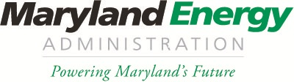
Maryland Natural Gas Voucher Program

Please fill out this “120 Day Extension Form” for the Maryland Natural Gas Voucher Program and send to:
Chris Rice via email: crice@energy.state.md.us
Or by mail to:
Attention- Nat Gas Voucher Program
“120 Day Form”
Maryland Energy Administration
60 West Street, Suite 300
Annapolis, MD 21401

Award #
Award Date
PPC Name
Motor Carrier Name
Vehicle Identification #
Original Vehicle Delivery Date
New Vehicle Delivery Date

Please provide a justification as to why an extension is required for vehicle delivery below:

