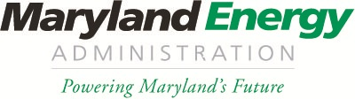
30 Day Form
Maryland Freedom Fleet Voucher Program
Larry Hogan, Governor
Boyd K. Rutherford, Lt. Governor
Mary Beth Tung, Director

Please fill out this “30 Day Form” for the Maryland Freedom Fleet Voucher Program, and send to:
Program Administration Rice via email: michael.jones1@maryland.gov
Or by mail to:
Attention- FFV Program
“30 Day Form”
Maryland Energy Administration
1800 Washington Boulevard, Suite 755
Baltimore, MD 21230

Award #
Award Date
PPC Name
Motor Carrier Name
Vehicle Identification #
Vehicle Delivery Date

